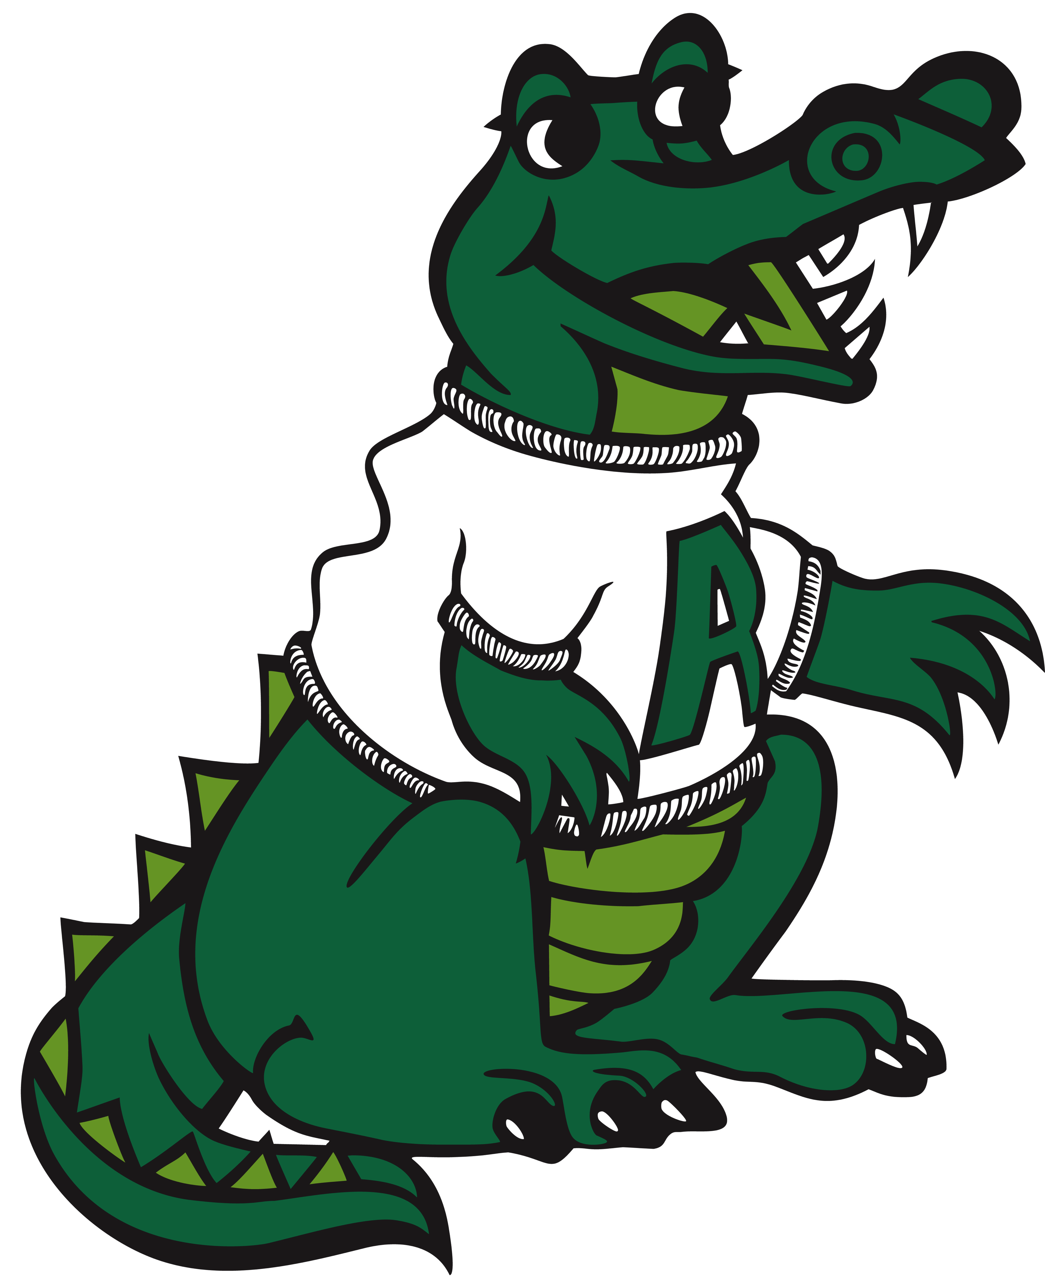

Adler Family Association
afa@d70schools.org

AFA Back to School Packet

Welcome to the 2019-2020 School Year!

Our Adler Family Association has an exciting year planned. This is our back-to-school communication.

We are pleased to introduce the 2019/2020 AFA Executive Board

Stacey Thermos: President
Cara Famighette: 1st VP
Dana Allan: 2nd VP
Jim Woodworth: Treasurer
Kathy Hodge: Secretary

We hope you will save the dates for the following upcoming activities:

The Adler Family BBQ will be held Thursday, August 22nd (flyer sent home separately). Purchase food at the event or bring a picnic meal to celebrate the start of school with our Adler community. Adler T-shirts, magnets and lawn signs will also be available for purchase (cash/check only).

Our first AFA meeting will be Monday, September 9th at 7pm.

Our Gator Gallop Fundraiser will be Sunday, September 15th. More details will be sent out at a later date.

Our first Dinner Night Out Fundraiser will be held at Culvers of Libertyville on Wednesday, September 11th. Our very own Adler Staff will be helping to serve food!

Adler Spirit Wear Online store will open late September/October with an opportunity to buy t-shirts, sweatshirts, PJs, and more! More info to come.

The packet also includes:
- AFA 2019-2020 Calendar
- Lunch Bunch Order Form

We look forward to working with all of our families this year. Please feel free to contact us with any questions or comments at afa@d70schools.org.

ADLER FAMILY ASSOCIATION (AFA) EVENTS 2019-2020 CALENDAR
(*May change due to weather)
August 22 (Thursday)
August 28 (Wednesday)
September 9 (Monday)
September 11 (Wednesday)
September 15 (Sunday)
October 16-17 (Wednesday & Thursday)
October 30 (Wednesday)
November 18 (Monday)
November 21 (Thursday)
December 3 (Tuesday)
December 7 (Saturday)
December 18 (Wednesday)
January 9 (Thursday)
January 13 (Monday)
February 1 (Saturday)
February 12-13 (Wednesday & Thursday)
February 19 (Wednesday)
March 9 (Monday)
March 18 (Thursday)
April 9 (Thursday)
April 23 (Thursday)
May 5 (Tuesday)
May 11 (Monday)
June 1 (Monday)*
June 2 (Tuesday)*
Back-to-school BBQ (6-7:30pm)
Curriculum Night
AFA Meeting (7 pm)
Dinner Night Out – Culver’s of Libertyville
Gator Gallop (2 -4pm) (Rain date 9/22 12 -2:30 pm)
Book Fair (3:00 - 8:30 pm)
Ice Cream Social (following Fall Concert - Grades 2 & 4)
AFA Meeting (7 pm)
Family Reading Night (6:30 pm)
Talent Show (7 pm)
Pancake Breakfast & Holiday Shoppe (8 - 11 am)
Marriott Field Trip (10:00 am - 12:30 pm)
Girls' Night Out (6:30 - 8:00)
AFA Meeting (7 pm)
Winter Carnival (9-12am) & Gator Raffle (12-1pm)
Book Fair (3:00 - 8:30 pm)
Guys' Night Out (6:30 - 8:00 pm)
AFA Meeting (7 pm)
Ice Cream Social (following Spring Concert - Grades 1,3 & 5)
Adler Art Show (during Open House)
Family STEM Night
Staff Appreciation Luncheon for Adler Staff (during school)
AFA Meeting (7 pm)
Field Day (9:30 am - 2:30 pm)
5th Grade Celebration (following Recognition Assembly)

The Adler Family Association Lunch Bunch Program is not only a great fundraiser for our school but also a convenience … We have partnered with four well-recognized, student-approved vendors who take care of lunch on Mondays (or Tuesday if Monday is a holiday)!
Two NEW notes for the 2019-2020 school year…
- We are excited to offer some GLUTEN FREE OPTIONS on the menu…
- ONLINE ENROLLMENT & PAYMENT IS REQUIRED!! Paper forms will no longer accepted… visit https://d70schools.revtrak.net/FA/AFA/#/list to place your order TODAY! This on-line ordering site is the ONE-STOP SHOP: sign up for Lunch Bunch, volunteer opportunities AND buy your school directory all on-line!!!
Deadline for enrollment and payment is Wednesday, August 28, 2019. NO EXCEPTIONS!
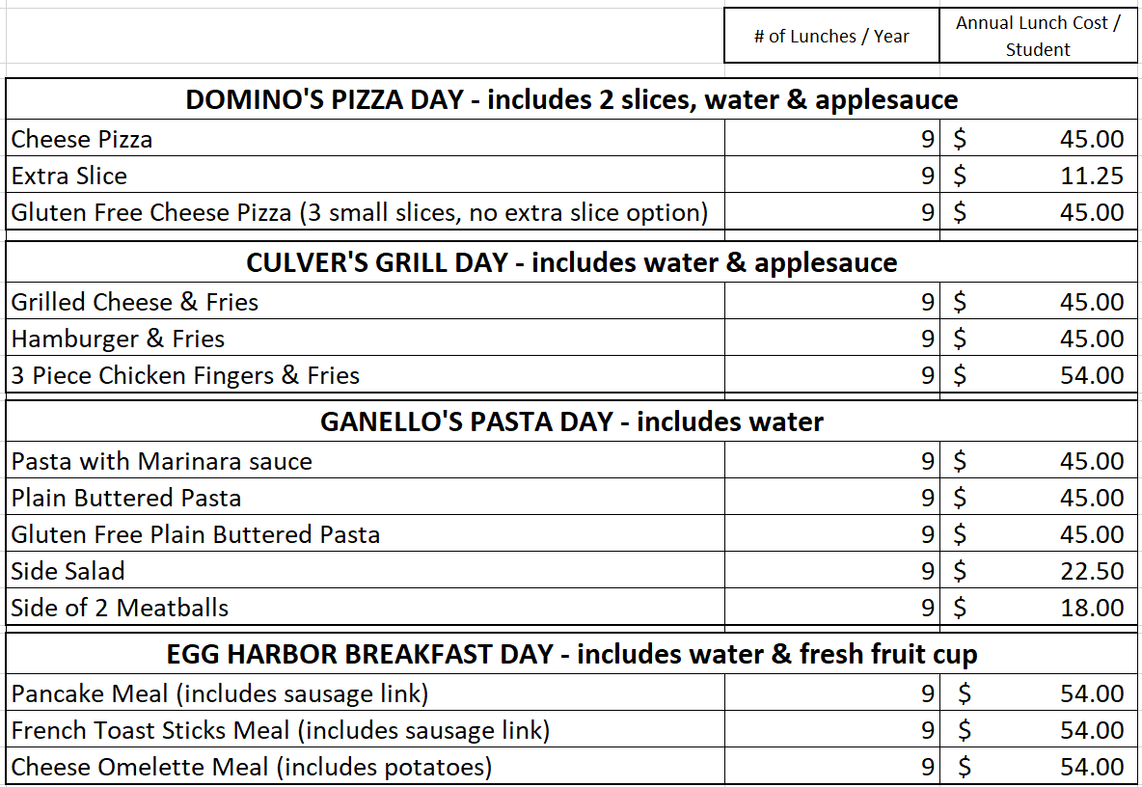

Are you interested in being a volunteer during Lunch Bunch? It is a 1 hour volunteering commitment approximately 5 times per year. If you would like to sign up – please look for the signup online!!! THANK YOU IN ADVANCE FOR YOUR HELP!

