The Adler Family Association Lunch Bunch Program is not only a great fundraiser for our school but also a convenience … We have partnered with four well-recognized, student-approved vendors who take care of lunch on Mondays (or Tuesday if Monday is a holiday)!
Two NEW notes for the 2019-2020 school year…
- We are excited to offer some GLUTEN FREE OPTIONS on the menu…
- ONLINE ENROLLMENT & PAYMENT IS REQUIRED!! Paper forms will no longer accepted… visit https://d70schools.revtrak.net/FA/AFA/#/list to place your order TODAY! This on-line ordering site is the ONE-STOP SHOP: sign up for Lunch Bunch, volunteer opportunities AND buy your school directory all on-line!!!
Deadline for enrollment and payment is Wednesday, August 28, 2019. NO EXCEPTIONS!
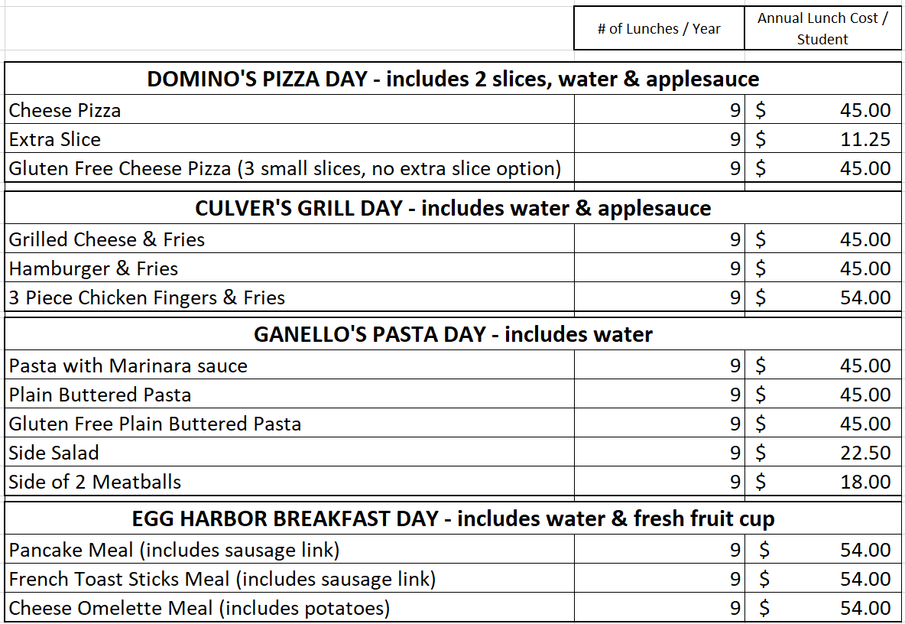

Are you interested in being a volunteer during Lunch Bunch? It is a 1 hour volunteering commitment approximately 5 times per year. If you would like to sign up – please look for the signup online!!! THANK YOU IN ADVANCE FOR YOUR HELP!

